**Types of Network Topologies**

**Objective of Task 1:**

**To understand what a network is and what types of networks there are**

1. Fill in the sheet by finishing of the sentence and defining how the network works in your own words.
2. find out the advantages and disadvantages of the type of networks
3. Use the internet to search for your answers and try using the correct terms.

**What is a Network?**  1 mark

Networks follow protocols, which define how communications are sent and received. These protocols allow devices to communicate. Each device on a network uses an Internet Protocol or IP address, a string of numbers that uniquely identifies a device and allows other devices to recognize it.

A **star network** communicates with the other computers on the network by 1 mark

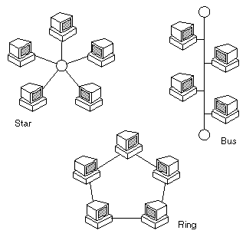

A star network is ran based off a switch. The switch in the centre is the main source of where all the computers are powered at. For example, the switch could be the internet and all the computers in the room are powered by it

..................................................................................................................................................

Advantages of a star network are: 1 mark

1. Easy to install, cheap

Disadvantages of a star network 1 mark

1. If the middle section shuts down, the others shut down as well

A **Bus network** communicates with the other computers on the network by 1 mark



A bus network is a local area network topology in which each node is connected to a main cable or link called a bus. All connected stations on the bus can communicate with all others on the singular network segment.

Advantages of a Bus network are: 1 mark

All sections can communicate with one and another

Disadvantages of a Bus network 1 mark

1. It has to stop at all sections until all data is completed

A **Ring network** communicates with the other computers on the network by 1 mark



A ring network is a network topology in which each node connects to exactly two other nodes, forming a single continuous pathway for signals through each node

Advantages of a Ring network are: 1 mark

1. Easy to install, cheap

Disadvantages of a Ring network 1 mark

1. If one section breaks/ shuts down, the others shut down as well

Total 10 Marks

**Extension task**

**Answer the questions and fill in the definitions left blank**

Which network type do you think is the best network system and why? 2 marks   
full mesh because it is all connected to one and another and if one of the cables break, there is many other routes it can follow until it get to the desired area

What is the difference between a local area network (LAN) and in what ways have Wide area networks (WAN) influenced our lives? 3 marks

LAN is only for a room of stuff, for example a computing classroom will be connected to one server in the centre and only them items will be there whereas a WAN is suitable for multiple areas and it can add new nodes to the area

Total 5 marks